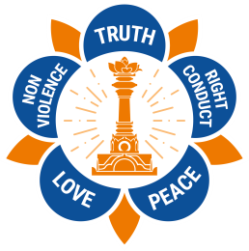
Sathya Sai International Organisation
15th February 2018
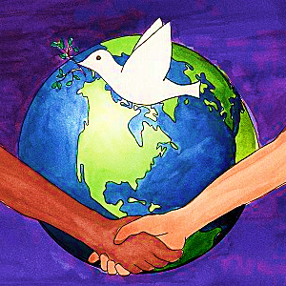

GLOBAL PEACE DAY INITIATIVES

‘Peace is what everyone seeks however cannot be obtained from the external world.
Peace can only be obtained from the inner source of peace within’. ~ Sathya Sai Baba

Dearest all,

Om Sri Sai Ram and Loving Greetings!

The Public Outreach Committee of the SSIO is very happy to share with you four inspiring initiatives to celebrate Global Peace Day, 21st September 2018.

PEACE MOVIE AWARD INTERNATIONAL CONTEST

The SSIO has been invited to participate in an international contest titled “PEACE MOVIE AWARD” (PMA) under the theme ‘Peace Begins with Me’. The initiative is organised by Sri Chinmoy Oneness-Home Peace Run Italy, a spiritual, non-profit, non-political and non-religious organisation founded in 1987 to promote peace and unity. The contest is for short ‘videos’ to capture ideas and aspirations on peace.

The Peace Movie Award is intended to promote peace with a video of 30 seconds maximum duration, which capture emotions, stories and aspirations that inspire and move us. The contest is open to everyone, age 6 and above, with special focus on young adults and school children. This is a beautiful opportunity for SSIO members around the globe, including Young Adults and children, to submit videos on Peace.

All videos must be sent by Dropbox or similar means to: public.outreach@sathyasai.org no later than 30th April 2018. Further technical details may be found in the attachment.

WALK FOR VALUES & PUBLIC MEETINGS

A second initiative to celebrate Global Peace Day on 21st September 2018 as a Public Outreach initiatives of the SSIO is to organise a “Walk for Values” on the value of Peace by inviting local schools, spiritual organisations, faith leaders, local authorities and the public to join the walk. As an alternative (or as part of the WFV) a Public Meeting on the value of Peace could be organised at national, regional and/or local levels by involving our communities.

Guidelines on how to organise Public Outreach events can be downloaded from www.sathyasai.org/poc-archive or you can contact us at poc@sathyasai.org

PEACE DRAWINGS, ARTWORKS & PHOTOS BY CHILDREN

At the 2017 Global Peace Day event organised by the Sri Chinmoy Oneness-Home Peace Run Italy in Rome, 7,500 drawings by school children from 38 countries around the globe were displayed in an exhibition at the Coliseum. Of these, 60 pictures were submitted by the SSIO of Croatia, Italy, Slovenia and Spain. Inspired by this event, we extend an invitation to SSE students at Sathya Sai Centres & Groups, Sathya Sai School students, students in local communities, and other children to create and submit artwork on Peace.

It is planned to display these artwork at Exhibitions (drawings); Public Meetings (posters); Walks for Values (banners); Social Media (leaflets), and Human Values Day on 24th April 2018.

All artwork must be submitted no later than 30th May 2018 indicating zone, country, name, age (and school if any) to: public.outreach@sathyasai.org

PEACE THEME SONG

The LASA team is urged to contribute to the Global Peace Day by composing songs on Peace. The best composed song (meaningful, catchy, etc.) could become the Global Peace Day theme song and be played at events around the world on 21st September 2018. The theme song could also be used by schools, published on the SSIO Website and social media and submitted to radio stations to celebrate the Global Peace Day. A 30-second video with the song refrain may be produced for the Peace Movie Award.

Songs should be submitted to public.outreach@sathyasai.org no later than 30th May 2018.

We recommend that SSIO events organised to celebrate Global Peace Day feature a common theme song on Peace (LASA) and exhibit artworks created by the children at public meetings, schools, public places. Such artwork can also be used as banners/placards at Walk For Values or shared on the Web/social media.
CONCLUSION

We urge the SSIO to enthusiastically participate in these four initiatives and request you to share this information with one and all. Please do not hesitate to reach out to us at public.outreach@sathyasai.org for more information or any questions.

Kindly ensure that all SSIO members in your area are informed about these initiatives and that this letter is circulated at all levels in your Zone, Region, Country, or Sub-region of the SSIO.

Thank you very much in advance for your loving support and collaboration.

With Love,
Alida Parkes & Pablo Tristan
SSIO Public Outreach Committee Co-chairs

Love All, Serve All

